Stage 2 Physics

Heating & Cooling Test

# **50 marks**

# **TIME**: 1 Hour

* A data sheet is supplied for student use

**NOTE:**

1. Calculations must show clear working with answers written in scientific notation stated to **three significant figures unless you are answering a question specifically asking you how many significant figures are technically required.**
2. Marks will be allocated for clear and logical setting out.
3. To help identify your answer, underline each answer.
4. State **assumptions** if working on open ended type questions.
5. Note that **NOT** all questions carry **equal** number of **marks**.
6. Answer **ALL** the questions.

Other constants required for this assessment:

Specific heat capacities of…

Aluminium = 900 J K-1 kg-1

Copper = 390 J K-1 kg-1

Plastic = 1670 J K-1 kg-1

Magnesium = 1050 J K-1 kg-1

Latent heat of Fusion of …

Lead = 2·5 × 104 J kg-1

1. A simple heat pack can be made by stuffing a bag with wheat grain and heating the bag in a microwave.  
   How much energy would a microwave need to supply to a wheat bag with a mass of 850 grams to increase the temperature by 28 °C if the specific heat capacity of wheat is 1509 J kg-1 °C-1? [2]

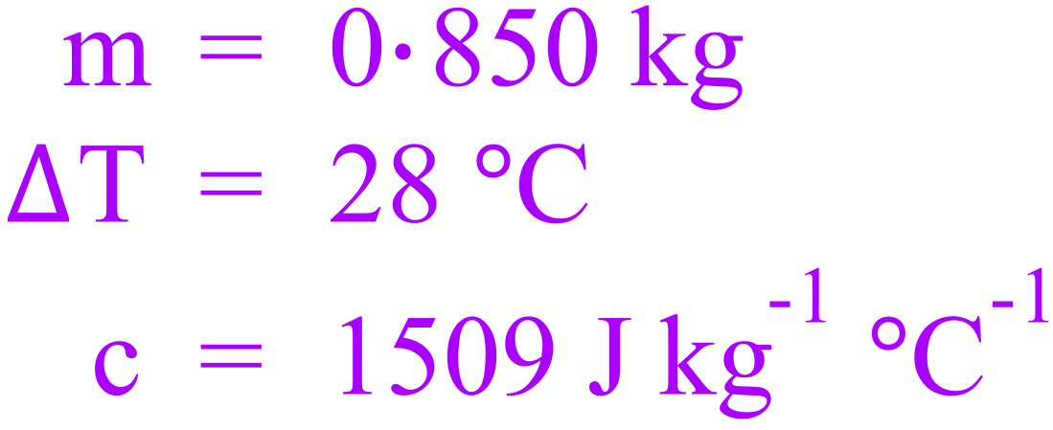 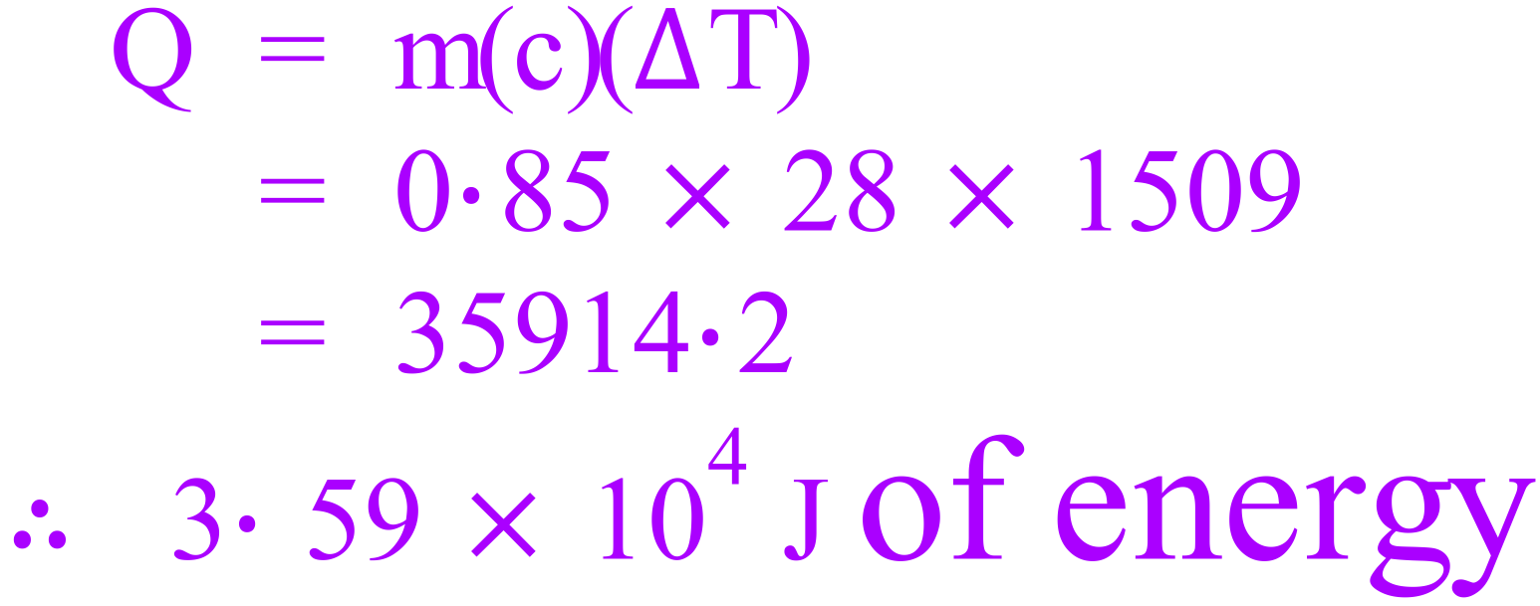

1. How much heat is absorbed by 0·155 kg of lead as it melts? [2]

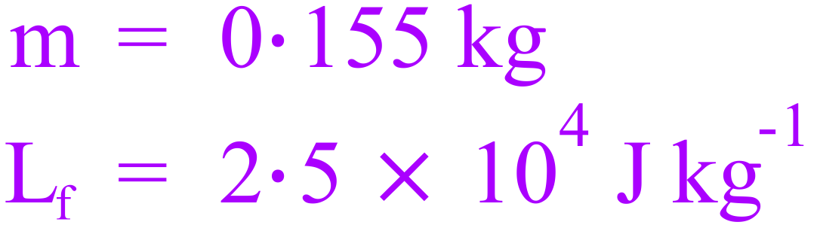 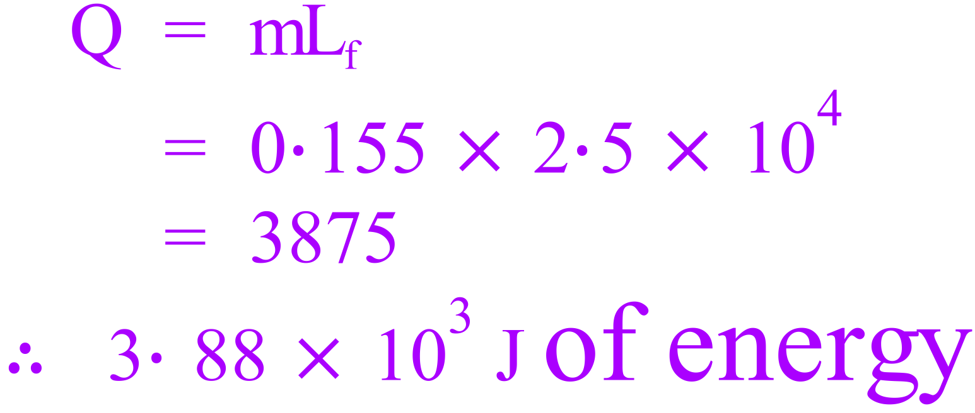

1. Using the models of matter explain the following:
   1. Why solids have a fixed shape but liquids and gases do not: [1]

The particles of a solid are held in a fixed lattice, so they are held relative to each other in a fixed position meaning that the whole object has a fixed shape [½].

The particles of liquids and gases are not held in a fixed position relative to each other, so the whole object does not have a fixed shape [½].

* 1. Why solids expand as they are heated: [1]

When heated the particles gain kinetic energy [½],

vibrate more rapidly and occupy more space [½].

1. During its recent mission on Mars the NASA rover “Curiosity” discovered a new substance. Curiosity was able to isolate 1 gram of the substance and began heating it from the surface temperature of -55 °C. The graph below represents a summary of the data collected.

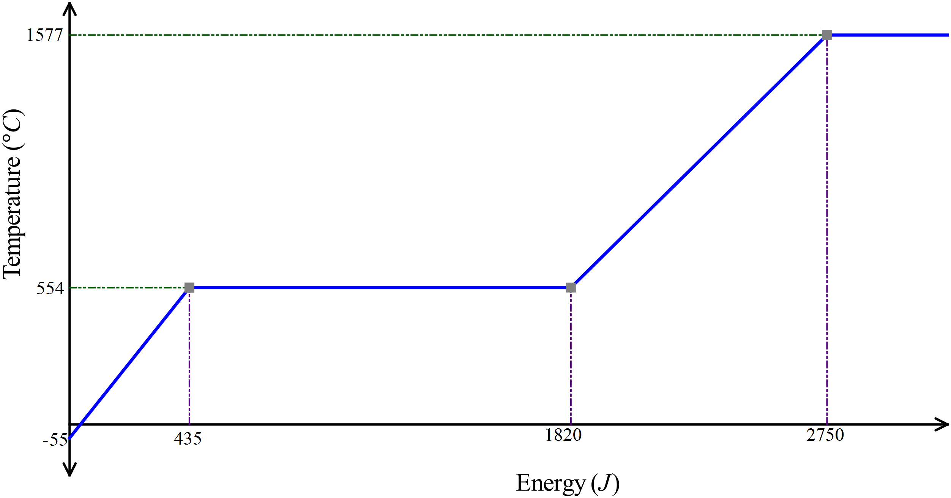

* 1. Explain why the temperature of the substance remains constant in the second part of the graph.  
      [3]

This part of the graph represents phase change (solid to liquid). [1]

The energy supplied goes into breaking up the crystalline structure (internal Potential energy). [½]

Temperature change is associated with change in internal kinetic energy. [½]

During phase change, internal potential energy is changed, not internal kinetic energy, therefore temperature remains constant. [1]

* 1. What is the melting point of this substance? [1]

554 °C [1]

* 1. What is the specific heat of the solid form of this substance? [3]

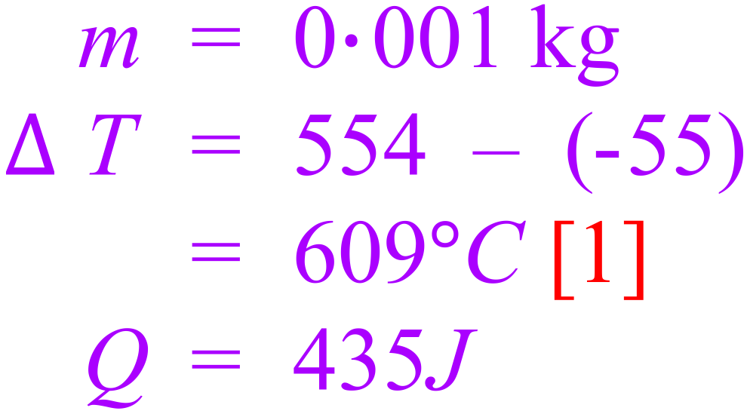 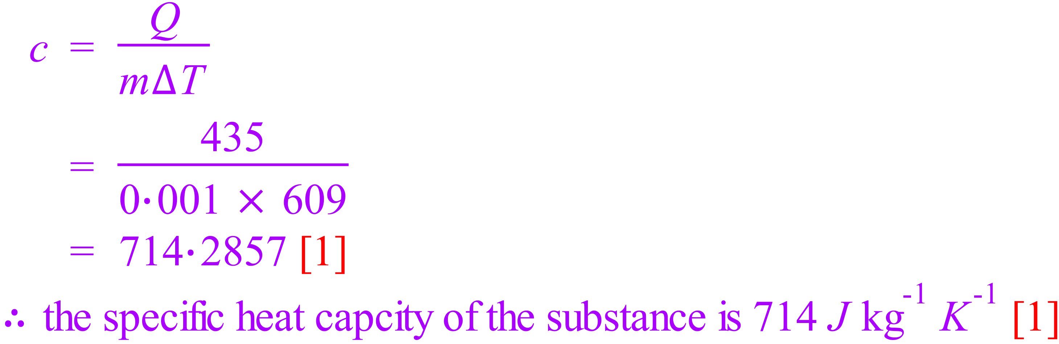

* 1. What is the latent heat of fusion for this substance? [3]

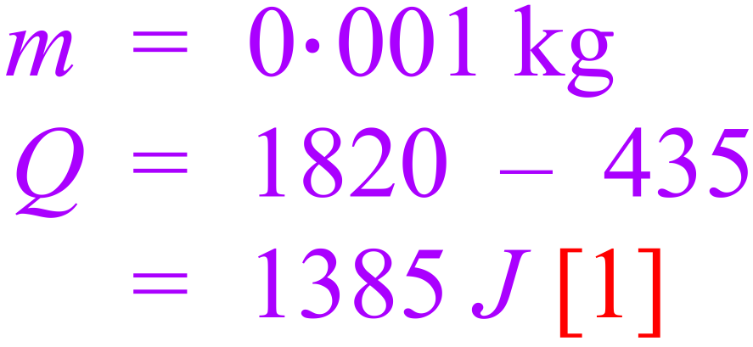 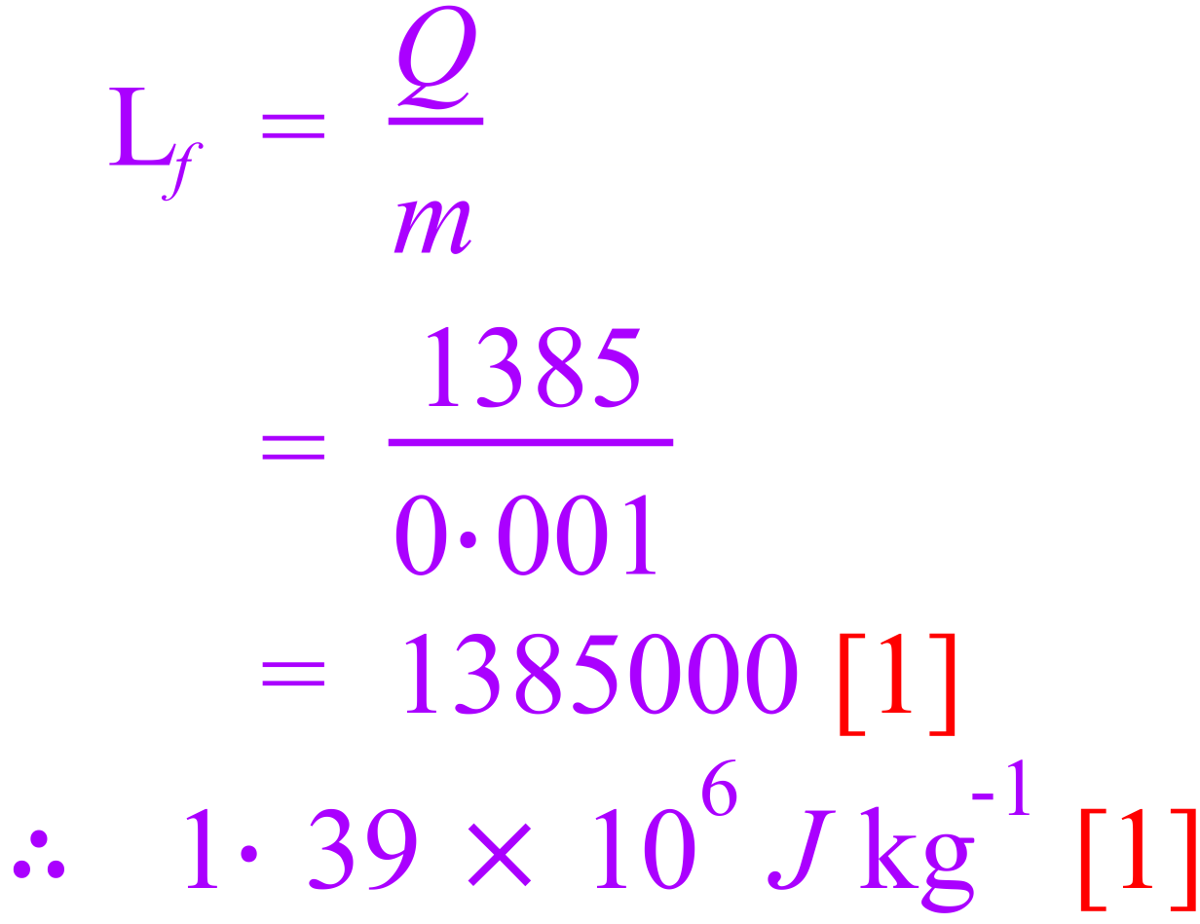

1. Like many animals, Kangaroos do not have sweat glands. Kangaroos have been observed to repeatedly lick their forearms, coating an area of skin/fur close to blood vessels with saliva, which is essentially water.  
   Referring to heat energy concepts explain why this behavioural adaptation will lower the body temperature of the kangaroo. [3]

The process of increasing the temperature and evaporation of the water in the saliva requires energy. [1]

The energy required comes from the body/blood of the kangaroo. [1]

This exchange of energy results in a lower body/blood temperature. [1]

Can’t decide which answer, above or below.

The water in the saliva evaporates [1]

The process of evaporation involves particles with the highest kinetic energy leaving, lowering the average kinetic energy (and temperature) of the remaining molecules [1].

Heat energy is transferred from the kangaroo’s blood to the cooler saliva [1].

1. Consider a brick wall that has been exposed to the Sun for some time:
   1. Heat is transferred from the sun via only radiation. Explain why no other method of heat transfer is possible: [2]

Space is a vacuum [½]

Convection[½] and Conduction [½] both require particles to transfer heat [½].

* 1. The air over the wall seems to shimmer and shake as air currents rise from it. Explain what creates these air currents. [2]

The air currents are caused by convection [1].

As air comes in contact with the wall, it is warmed (becomes less dense) and rises [1].

* 1. You can feel the wall’s warmth some distance away. How does this heat get to you through the air? [1]

Radiation

* 1. Which would you expect to be warmer after being exposed to the Sun for equal times – a white wall or a black wall? Explain. [3]

The black wall [1]

Black absorbs [1], white reflect radiation, [1]

1. Distinguish between the following:
   1. Heating and Heat: [1]

Heating is the process of transferring internal energy from a hotter body to a colder body [½]

While this internal energy is being transferred it is referred to as heat [½].

* 1. Internal energy and temperature: [1]

Internal energy is the sum of the particles kinetic and potential energies [½].

Temperature refers to (or is a measure of) the average kinetic energy of the particles [½]

1. A sample of magnesium is heated at a constant rate. The graph below shows how its temperature varies with time.

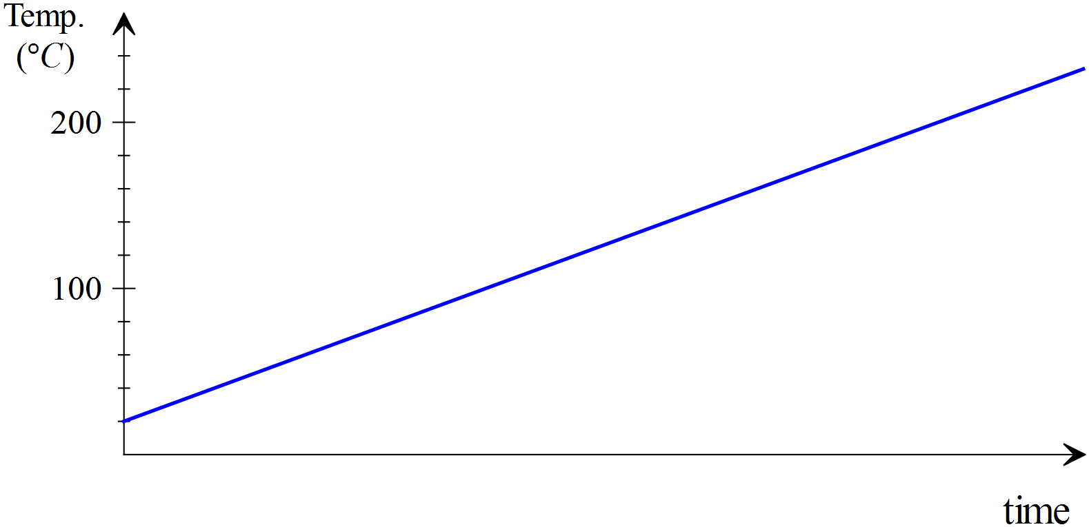

* 1. If an equal mass of copper at the same initial temperature is heated at the same rate, then the copper graph will be: **[select one of the following by ticking the corresponding box]** [1]
     1. Identical to the magnesium graph. □
     2. Steeper in slope. 🗹
     3. Less steep in slope □
  2. Explain your answer to ‘a’ [2]

The specific heat of copper is less than magnesium [1],

The same amount of energy will cause a greater temperature change. [1]

1. Which absorbs more heat? 15 grams of water or 150 grams of copper when they both experience a 5 °C increase in temperature. [3]

The specific heat of water is more than ten times the specific heat of copper [1], given that the mass of water is one tenth of the copper [1], the water would absorb more energy for the same temperature change [1].

Or calculate the actual energy absorbed by each.

1. A 600 W camp-stove heats 0·75 kg of water in a 300 g aluminium kettle for 10 minutes from a starting temperature of 15 °C.
   1. How much energy is supplied to the kettle if the camp-stove is 75% efficient at transferring heat to the kettle? [2]

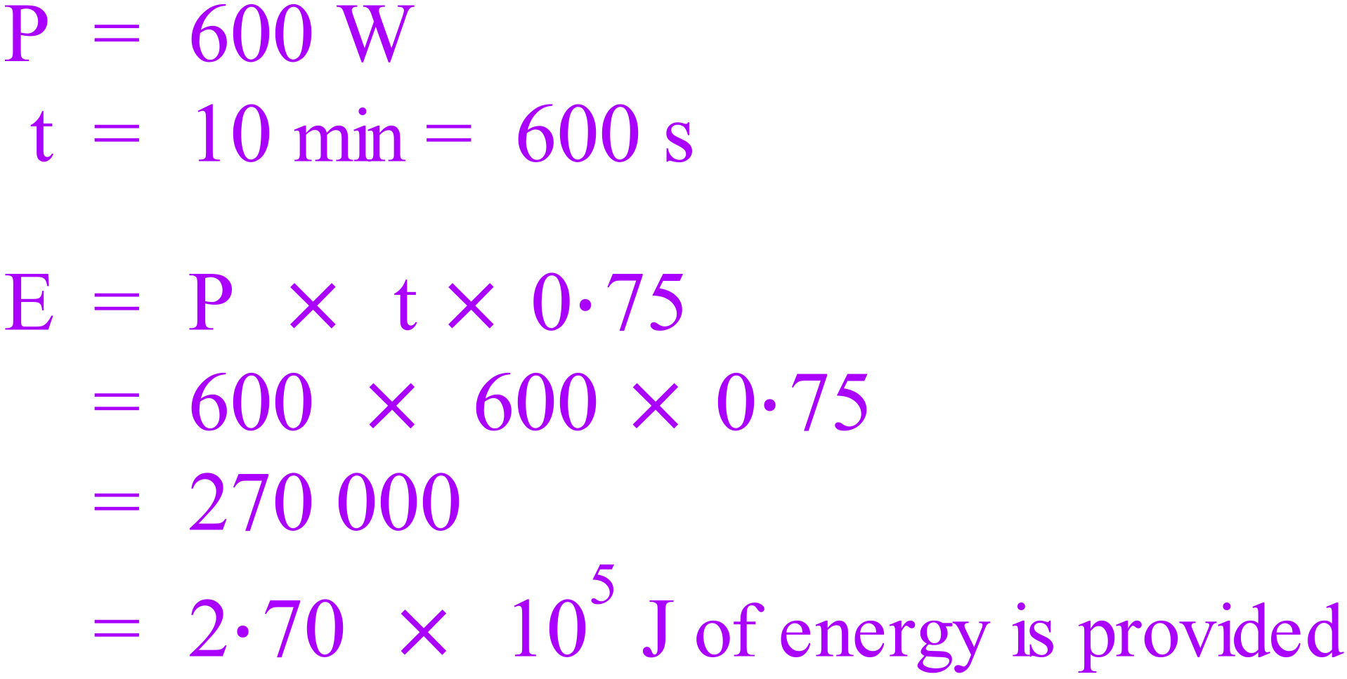

* 1. Will the water in the kettle come to the boil? [2]

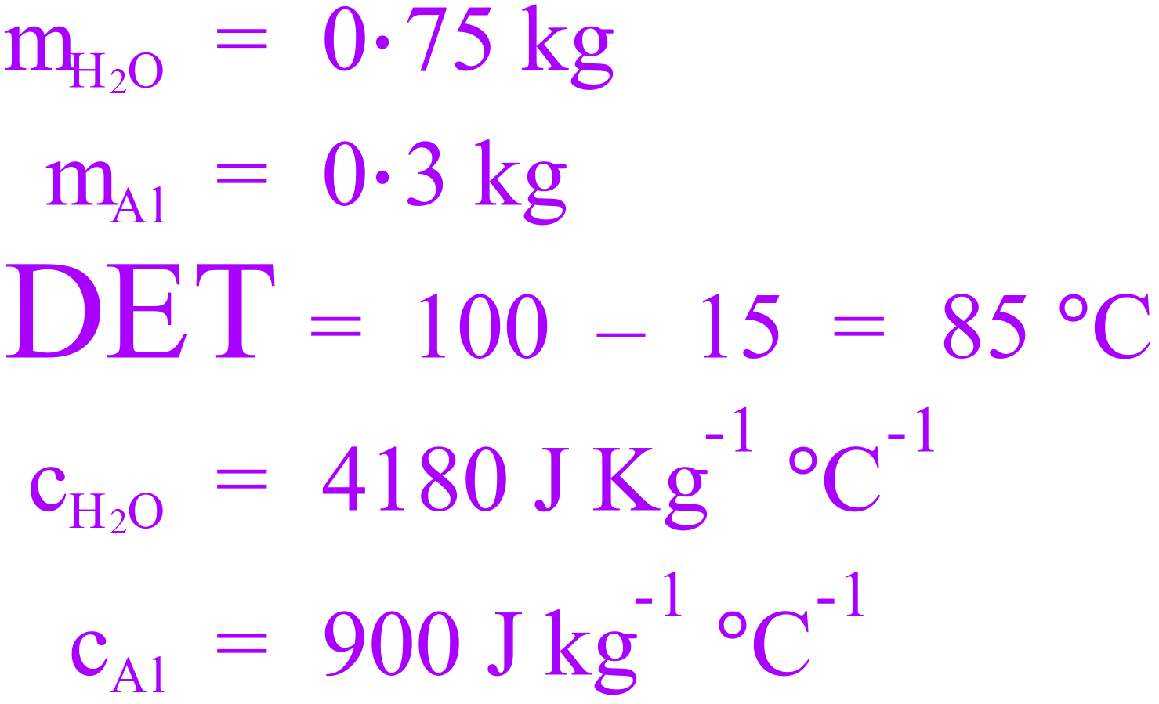 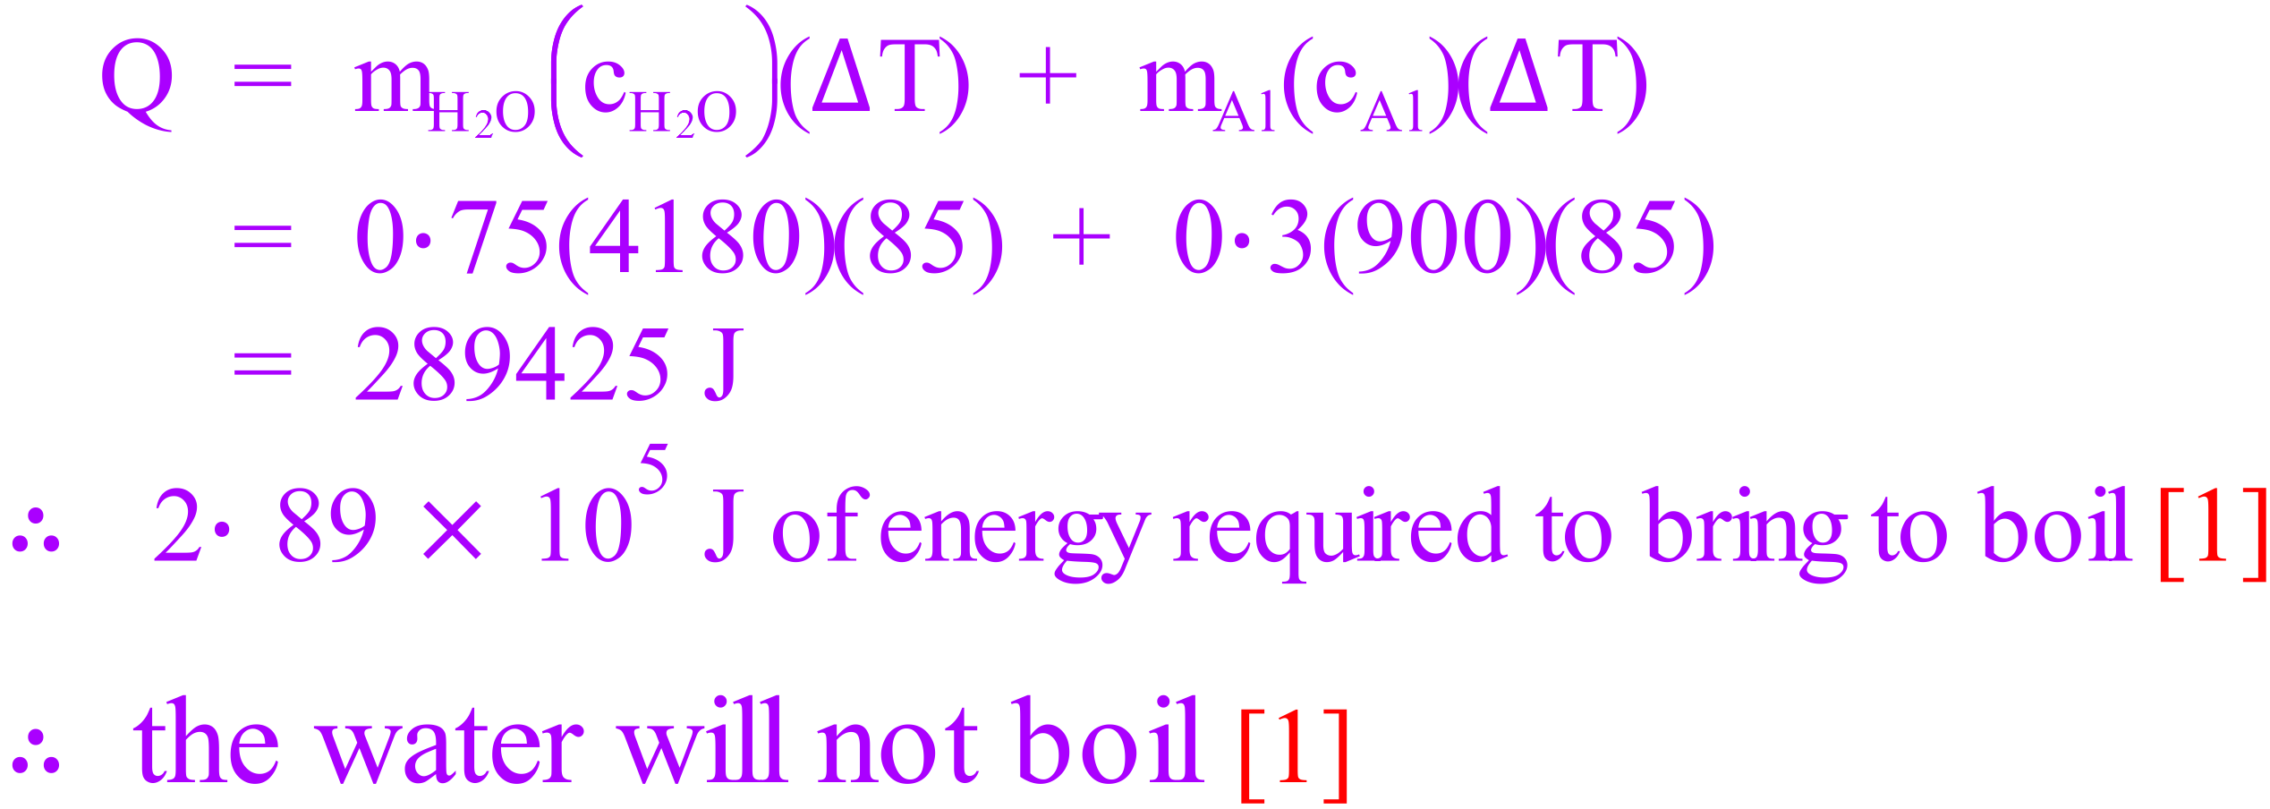

Alternatively use the answer to part a. to calculate the ΔT and/or TF to determine if the water will boil.

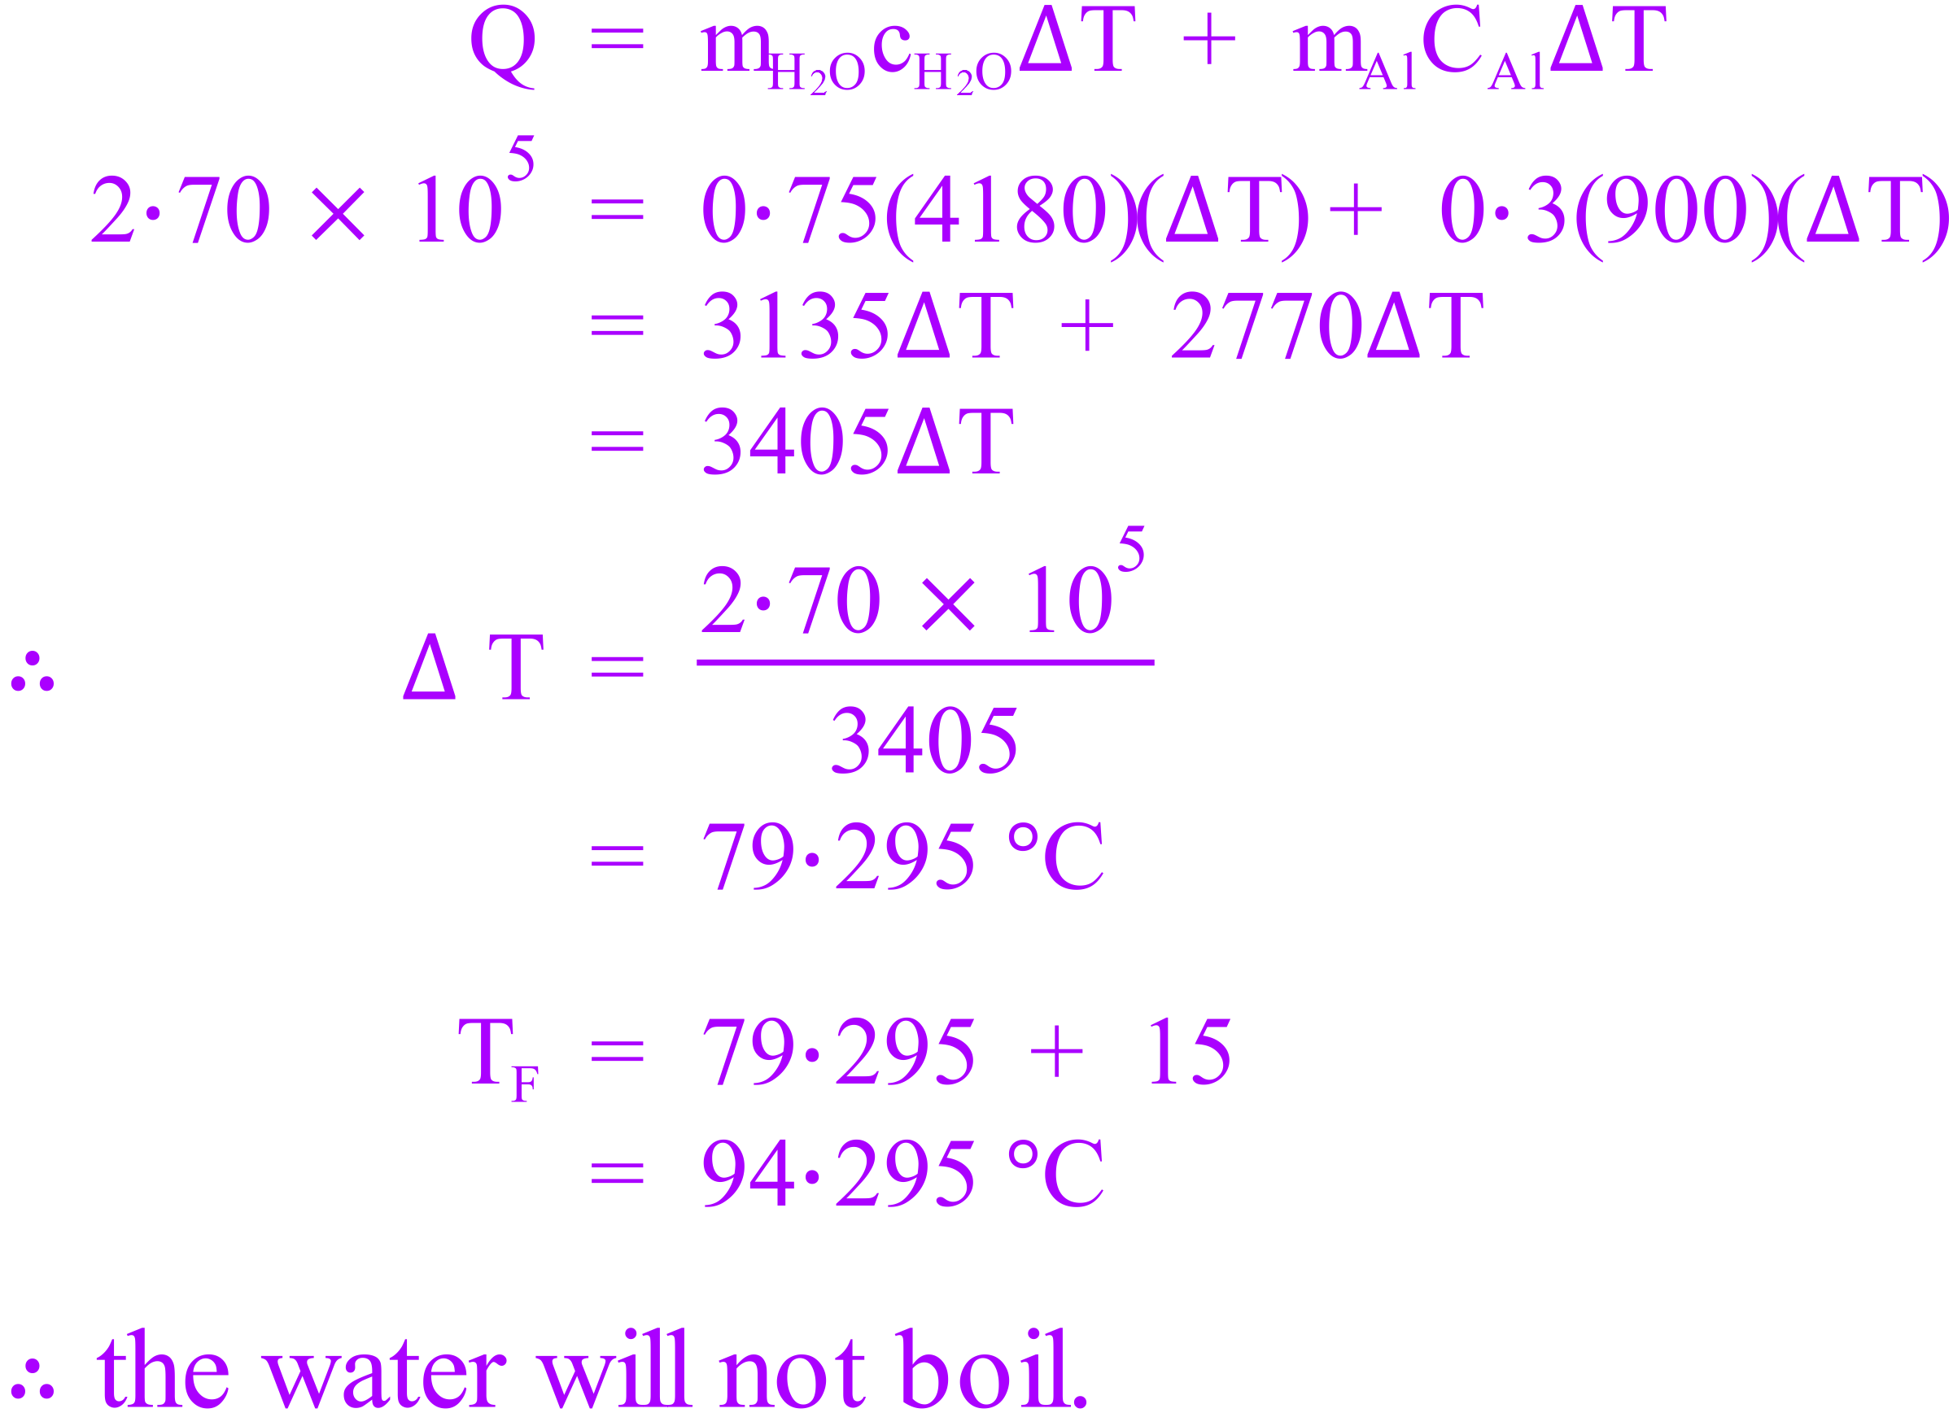

1. The safe bathing temperature for a new born baby is 36 °C. A mother of a new-born baby adds 1·5 litres of water with a temperature of 65 °C to a 2·3 kg plastic baby bath which is at room temperature (17 °C).
   1. What will the temperature of the water be when the water and bath reach thermal equilibrium?  
       [3]

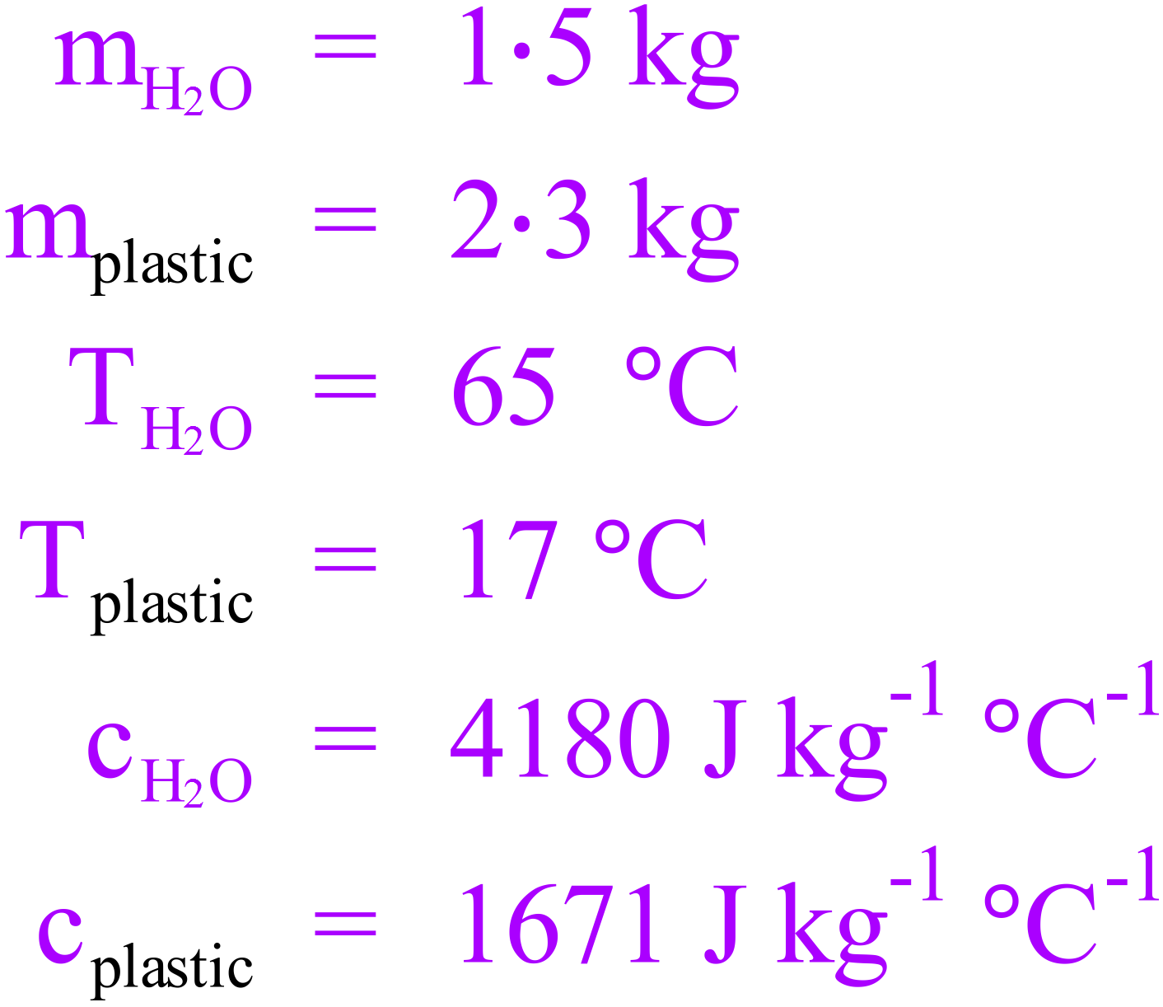 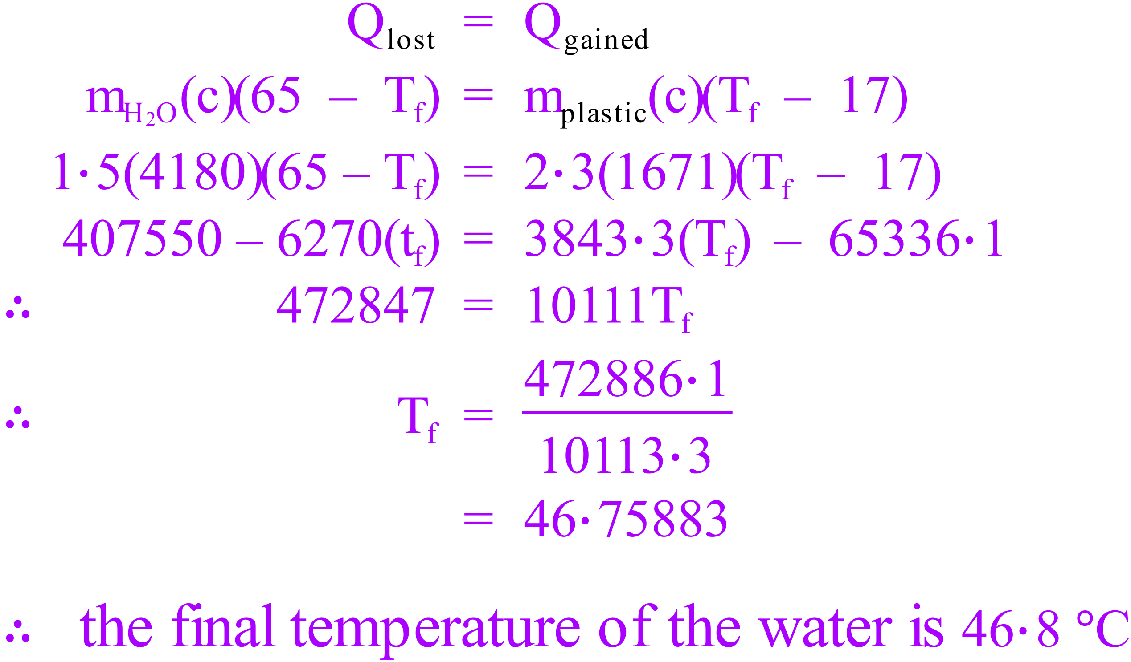

* 1. How much cold water [@ 22 °C] needs to be added to make the temperature of the water safe for the new-born baby? [3]

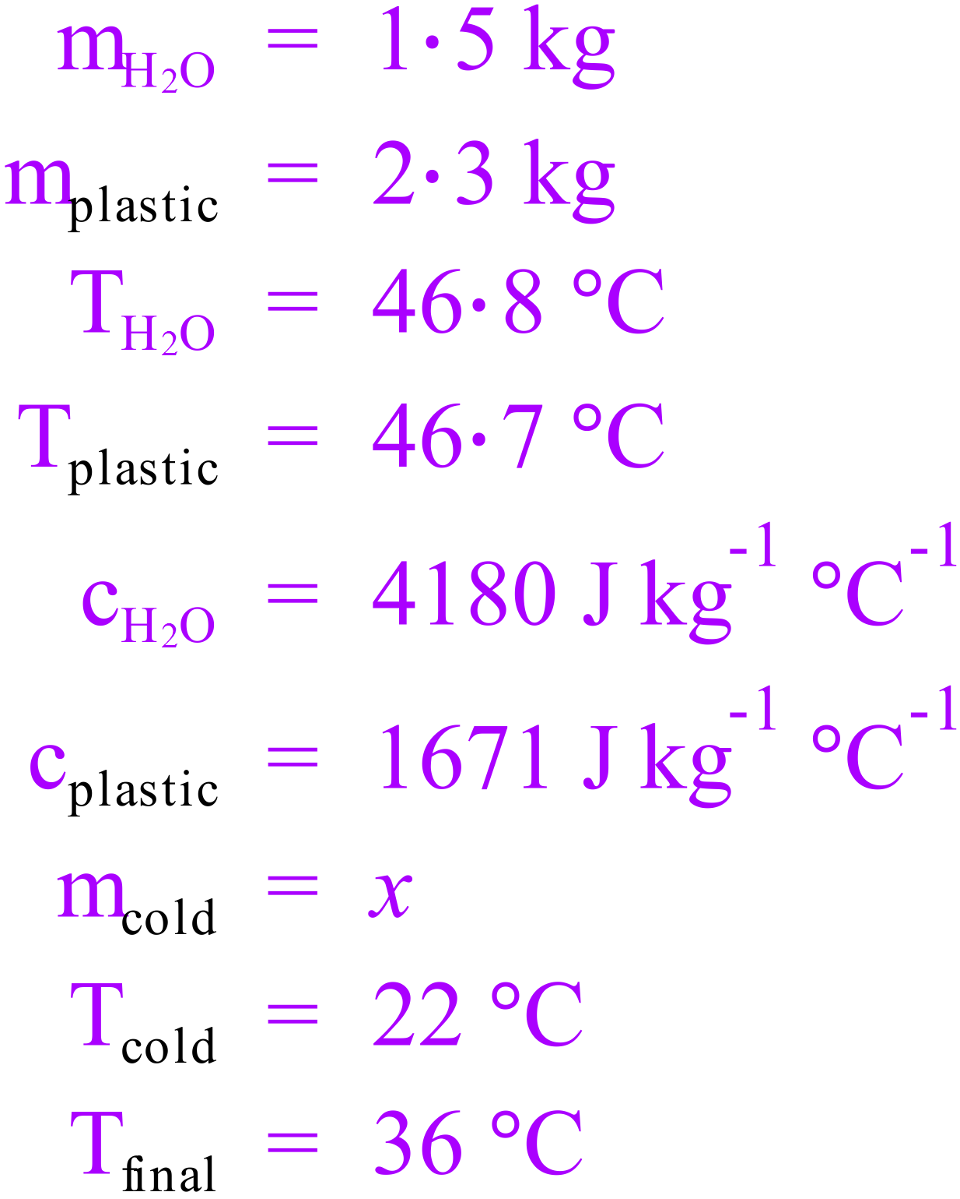 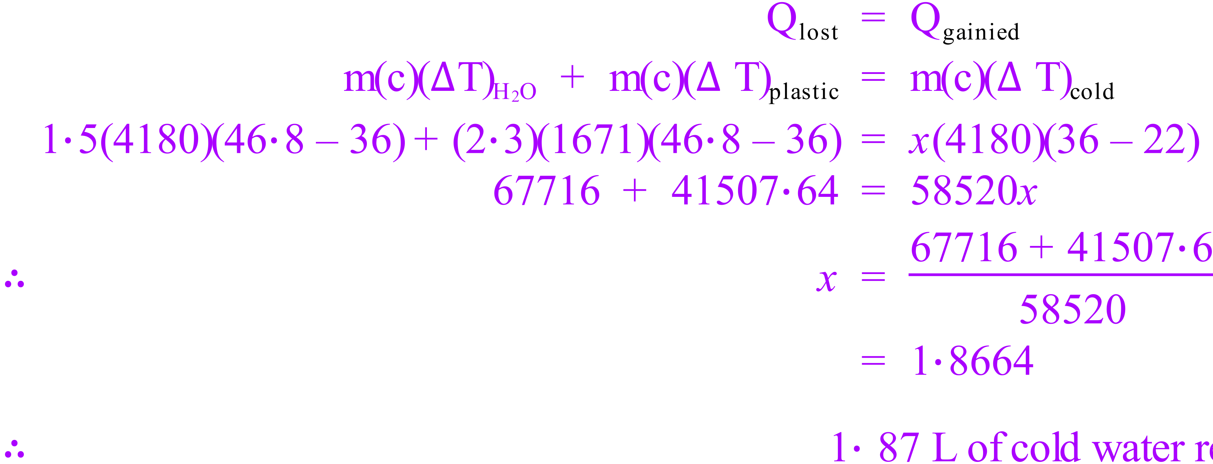

Alternate answer if 50 °C is used = 2.4189 L of water

1. How much steam at 100 °C must be added to 40·0 g of ice at -6·00 °C in an insulated aluminium calorimeter of mass 53·0 g so that the ice melts and the final temperature of all the water is 5·5 °C.  
   [cAl = 900 J kg-1 °C-1] [5]

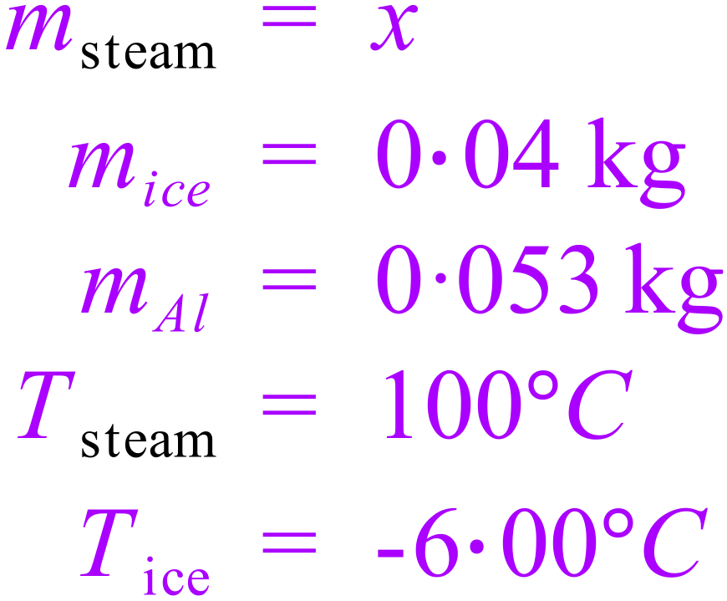 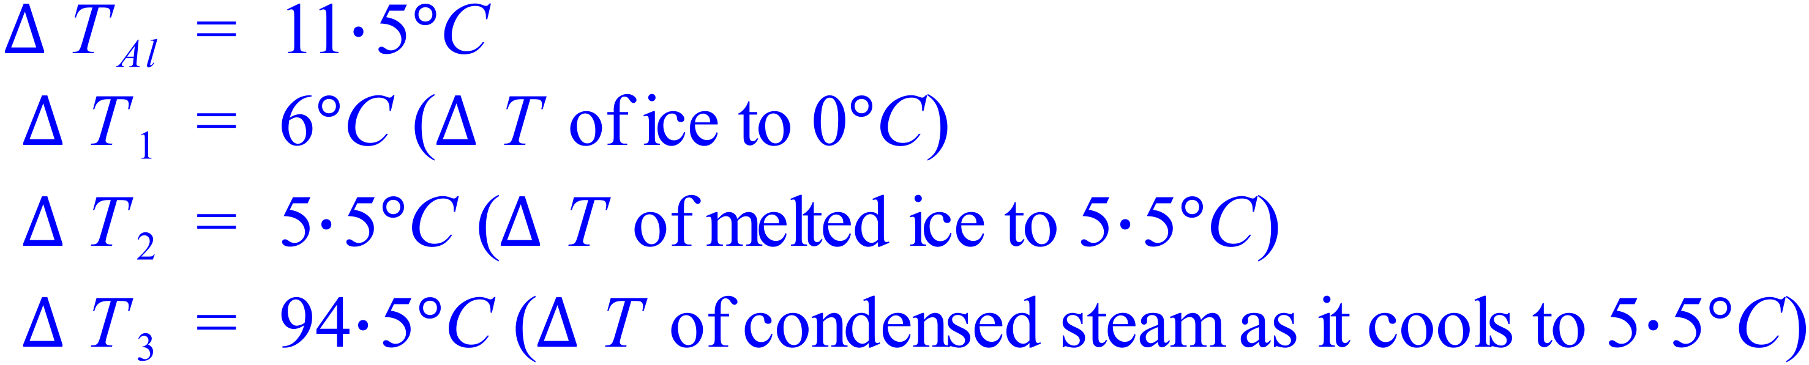

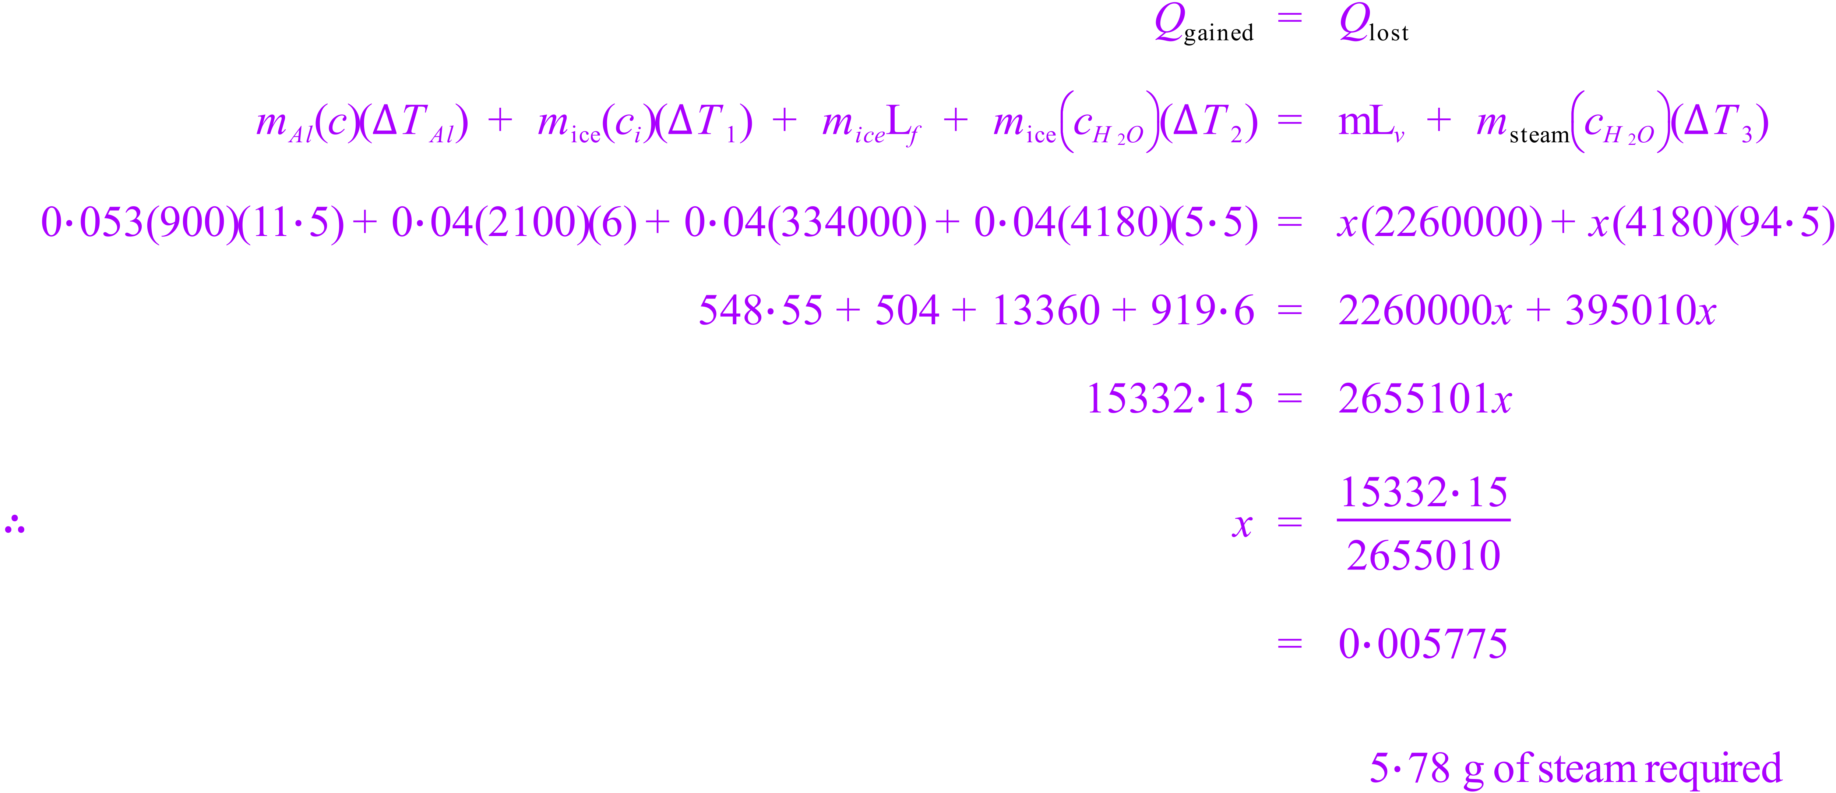 End of Test